**FACE MASK DETECTION SYSTEM**

Minor project report submitted in partial fulfilment of the requirement for the degree of Bachelor of Technology

in

# Computer Science and Engineering

By

## PRIYANSH AGARWAL (201480)

## SHUBHAM DHIMAN (201372)

## PUNEET KATOCH (201385)

**UNDER THE SUPERVISON OF**

Dr. Abhilasha Sharma



Department of Computer Science & Engineering and Information Technology

# Jaypee University of Information Technology, Waknaghat, 173234, Himachal Pradesh, INDIA

**TABLE OF CONTENT**

**Content Page No.**

Declaration I

Certificate II

Acknowledgement III

Abstract IV

**CHAPTER 1: Introduction**

* 1. Introduction 1

1.2 Motivation 2

1.3 Objective 2

1.4 Language Used 3

1.5 Technical Requirements (Hardware) 3

1.6 Outcomes 4

**CHAPTER 2: Literature Survey**

2.1 Feasibility Study 5

2.2 Requirements 7

2.3 Data Flow Diagram 8

2.4 Model Architecture 9

**CHAPTER 3: Implementation**

3.1 Dataset Used 11

3.2 Description of the Dataset 11

3.3 Design of the problem Statement 11

3.4 Algorithm/Pseudocode of the project problem 12

3.5 Flow graph of the minor project 14

3.6 Screenshots of the various stages of the project 15

**CHAPTER 4 : Results**

4.1 Results Achieved 22

4.2 Applications of the project 24

4.3 Limitation of the project 24

4.4 Future Work 25

4.5 Conclusion

**References**

**DECLARATION**

I hereby declare that, this project has been done by me under the supervision of Dr. Abhilasha Sharma, **Affiliation,** Jaypee University of Information Technology. I also declare that neither this project nor any part of this project has been submitted elsewhere for award of any degree or diploma.

**Supervised by:**

**(Dr. Abhilasha Sharma)**

Assistant Professor (SG)

Department of Computer Science & Engineering and Information Technology

Jaypee University of Information Technology

**Submitted by:**

**Priyansh Agarwal (201480)**

**Shubham Dhiman (201372)**

**Puneet Katoch (201385)**

Computer Science & Engineering Department

Jaypee University of Information Technology

**CERTIFICATE**

This is to certify that the work which is being presented in the project report titled “Face mask detection system” in partial fulfilment of the requirements for the award of the degree of B.Tech in Computer Science And Engineering and submitted to the Department of Computer Science And Engineering, Jaypee University of Information Technology, Waknaghat is an authentic record of work carried out by “Priyansh Agarwal(201480) , Shubham Dhiman(201372), Puneet Katoch(201385) .” during the period from January 2023 to May 2023 under the supervision of Dr. Abhilasha Sharma, Department of Computer Science and Engineering, Jaypee University of Information Technology, Waknaghat.

Priyansh Agarwal (201480)

Shubham Dhiman (201372)

Puneet Katoch (201385)

The above statement made is correct to the best of my knowledge.

(Dr. Abhilasha Sharma)

Assistant Professor (SG)

Computer Science & Engineering and Information Technology

Jaypee University of Information Technology, Waknaghat,

**AKCNOWLEDGEMENT**

Firstly, I express my heartiest thanks and gratefulness to almighty God for His divine blessing makes us possible to complete the project work successfully.

I really grateful and wish my profound my indebtedness to Supervisor **Dr. Abhilasha Sharma, Assistant professor (SG)**, Department of CSE Jaypee University of Information Technology, Wakhnaghat. Deep Knowledge & keen interest of my supervisor in the field of “**Research Area**” to carry out this project. Her endless patience, scholarly guidance, continual encouragement, constant and energetic supervision, constructive criticism, valuable advice, reading many inferior drafts and correcting them at all stage have made it possible to complete this project.

I would like to express my heartiest gratitude to **Dr. Abhilasha Sharma,** Department of CSE, for his kind help to finish my project.

I would also generously welcome each one of those individuals who have helped me straight forwardly or in a roundabout way in making this project a win. In this unique situation, I might want to thank the various staff individuals, both educating and non-instructing, which have developed their convenient help and facilitated my undertaking.

Finally, I must acknowledge with due respect the constant support and patients of my parents.

Priyansh Agarwal (201480)

Shubham Dhiman (201372)

Puneet Katoch (201385)

**ABSTRACT**

 COVID-19 pandemic caused by novel coronavirus is continuously spreading until now all over the world. The impact of COVID-19 has fallen on almost all sectors of development. The healthcare system is going through a crisis. Many precautionary measures have been taken to reduce the spread of this disease where wearing a mask is one of them. In this paper, we propose a system that restricts the growth of COVID-19 by finding out people who are not wearing any facial mask in a smart city network where all the public places are monitored with CCTV cameras. When a person who is not wearing a mask is detected, the city network gives a permission number. The deep learning architecture is trained on a dataset containing images of masked and unmasked people collected from various sources. It is hoped that our research will be an important tool in reducing the spread of this disease in many countries around the world.

The corona virus COVID-19 pandemic is causing a global health crisis so the effective protection methods is wearing a face mask in public areas according to the World Health Organization (WHO). The COVID-19 pandemic forced governments across the world to impose lockdowns to prevent virus transmissions. Reports indicate that wearing facemasks while at work clearly reduces the risk of transmission. We will use the dataset to build a COVID-19 face mask detector with computer vision using Python, OpenCV, and Tensor Flow and Keras. Our goal is to identify whether the person on image or video stream is wearing a face mask or not with the help of deep learning architecture.

The face mask detection system uses deep learning algorithms, such as convolutional neural networks (CNNs), to identify faces in images or video feeds. These algorithms uses many training images to learn the features of a face, including the presence or absence of a mask. The system can be trained using both masked and unmasked faces to improve its accuracy.

**Chapter 01: INTRODUCTION**

**1. 1 Introduction**

A new type of virus, not previously identified in people, is a novel coronavirus. Coronaviruses are a large family of viruses that cause diseases ranging from the common cold to deadly diseases such as Middle East Respiratory Syndrome (MERS) and Severe Acute Respiratory Syndrome (SARS). In December 2019, patients were diagnosed with the first coronavirus. Since then, COVID-19 has become a global epidemic. People all over the world are facing challenges due to this pandemic. Every day, people are infected. Approximately 687,565,847 cases have been confirmed, including 6,128,421 deaths [1]. This number is increasing day by day. The main symptoms of coronavirus announced by the World Health Organization (WHO) are fever, dry cough, fatigue, diarrhea, loss of smell and taste.

Many measures have been taken to prevent the spread of the coronavirus. Wearing a mask is the easiest. COVID-19 is a disease that can spread from one person to another. This disease can be controlled by using a suitable face mask. If people strictly maintain social distancing and wear a face mask, the spread of COVID-19 can be limited. It is very sad to see that people do not follow these rules properly and this accelerated the spread of this virus. Checking and reporting those who do not comply with the law to the relevant authorities may be a solution to reduce the spread of the coronavirus.

Mask Detection is a way to detect if someone is wearing a mask. Deep learning techniques are widely used in medical practices. This model can be used to describe facial expressions. In addition, smart city refers to a city area with many IoT sensors for data collection. These records are used for different functions throughout the city. This includes monitoring traffic, electricity, water connections and more. Recently, the spread of COVID-19 can be reduced by facial recognition in the smart city network.

This model is designed to develop a method to detect whether people wear masks in the smart city and then inform the required authority to take necessary action towards the people who are not wearing face masks. First, 4,444 different public spaces across the city were recorded in real time using 4,444 CCTV cameras. Facial images were extracted from this video and used to describe facial expressions. Learning Algorithm Convolutional Neural Network (CNN) is used to extract features from images and then learn these features from multiple hidden layers. When the organization detects unmasked people, this information is sent to the appropriate organization by the city network to take the necessary action. The proposed system evaluated the promising results of data collected from various sources. In addition, we represent a system that ensures that people who do not comply with health rules comply with the law in case of pandemic.

* 1. **Motivation**

The motivation for developing a face mask detection system is the ongoing COVID-19 pandemic. One of the primary measures recommended by health authorities to prevent the spread of the virus is wearing face masks in public places. However, it is challenging to ensure that everyone is complying with this recommendation, especially in crowded areas such as airports, hospitals, and schools.

By developing a face mask detection system, we can automate the process of monitoring whether people are wearing face masks or not. This can be done using surveillance cameras in public places, which can alert authorities if someone is not wearing a face mask. This system can help reduce the spread of the virus, as well as provide a sense of security and safety for the public. Additionally, the system can help enforce face mask regulations, which can ultimately lead to a quicker recovery from the pandemic.

**1.3 Objective**

The objective of a face mask detection system model is to accurately detect whether a person is wearing a mask or not. The model should be able to analyze images or video feeds and identify if the person's face is covered with a mask or not. The main purpose of such a system is to help enforce mask-wearing policies in public spaces to reduce the spread of infectious diseases. It can be used in various settings such as hospitals, airports, schools, public transportation, and other public spaces.

The primary goal of the face mask detection system model is to ensure that individuals are following health and safety protocols, as recommended by public health officials. Additionally, the system can provide a tool for organizations to monitor and enforce mask-wearing policies in real-time.

**1.4 Language Used**

In this project all the required models have been implemented using python programming. Several libraries supported by python and algorithms have been used in our model to create our desired project and to develop a reliable and accurate face mask detection system.

**1.5 Technical Requirements (Hardware)**

Refers to the computer hardware specifications that defines the computer’s components and capabilities. Model, processor speed and manufacturer. The lesser the processor speed the faster the pc. Random access memory (GB). ROM(GB). Input devices: Input devices such as a mouse or keyboard are necessary to input text into the recognition system and to edit the recognized text as needed. Network connection: In some cases, a network connection may be required to access and process large datasets or to connect to cloud-based recognition services.

**1.6 Outcomes**

The outcomes for a face mask detection system are the tangible and intangible results that the system produces. Here are some of the key deliverables/outcomes of a face mask detection system:

1. Increased safety: The primary outcome of a face mask detection system is increased safety for individuals in public spaces. By accurately detecting whether individuals are wearing masks, the system can help prevent the spread of infectious diseases, including COVID-19.

2. Compliance monitoring: Face mask detection systems can monitor compliance with mask-wearing policies in public spaces, such as airports, shopping malls, and government buildings. This helps ensure that individuals are following public health guidelines and regulations.

3. Automation: Face mask detection systems automate the process of monitoring whether individuals are wearing masks. This eliminates the need for human intervention and saves time and resources.

4. Alerting mechanism: The system can send alerts to security personnel or law enforcement in case of non-compliance, suspicious behavior, or potential security threats.

5. Data collection: The system can collect data on the number of people wearing masks, compliance rates, and other metrics. This data can be used to analyze trends and patterns and make informed decisions about public health policies.

Overall, the key outcomes of a face mask detection system are increased safety, compliance monitoring, automation, alerting mechanism, data collection, improved public trust, and customizability. These outcomes can help public health officials, law enforcement, and security personnel to make informed decisions and ensure public safety.

**Chapter 02: Feasibility Study, Requirements Analysis and Design**

**2.1 Feasibility Study**

**2.1.1 Problem Definition**

To design a face mask detection system that can accurately identify whether a person is wearing a mask or not in real-time.

**2.1.2 Problem Analysis**

Face mask detection is an essential task for ensuring public safety, especially during pandemics or in crowded spaces. The goal is to develop a model that can accurately classify whether individuals are wearing face masks or not. The model takes images or video frames as input and outputs a binary classification ("Mask" or "No Mask") along with a confidence score. The process involves collecting a diverse dataset, preprocessing the data, selecting a suitable deep learning model, designing the model architecture, training the model, and evaluating its performance using metrics like accuracy and precision. Deployment includes saving the trained model and developing an application for real-time mask detection. Continuous improvement involves updating the model with new data and monitoring its performance. Face mask detection models contribute to enforcing safety measures, reducing manual monitoring efforts, and promoting public health and safety.

**2.1.3 Solution**

This solution would involve using advanced image processing and recognition algorithms that can accurately analyze face mask detection model. The software solution would be designed to be efficient, accurate, and user-friendly, and could potentially provide significant benefits in terms of time savings and increased accuracy compared to other models. Identify the challenges or issues that may arise during the implementation of the face mask detection system. This could include factors such as varying lighting conditions, different types of face masks and real-time performance. Explore existing solutions and technologies that address face mask detection and consider different algorithms and models suitable for face mask detection. This could include computer vision techniques, deep learning approaches such as convolutional neural networks, or a combination of both.

**2.1.4 Literature Survey**

|  |  |  |  |  |
| --- | --- | --- | --- | --- |
| **Ref No.** | **Problem** | **Methodology** | **Work done** | **Accuracy** |
| [1] | FACE MASK  DETECTION USING  YOLOV5 | SR-YOLOv5 | USED YOLOV5  PRETRAINED MODEL FOR  IDENTIFYING A PERSON  HAS WEAR MASK OR NOT. | ACCURACY  OBTAINED=  =93.4% |
| [2] | FACE MASK  DETECTION USING  DEEP LEARNING | DEEP  LEARNING | USED DEEP LEARNING TO  IDNTIFY MASK WEARING  PEOPLES. | ACCURACY  OBTAINED=  98.7% |
| [3] | FACE MASK  DETECTION USING  COMPUTER VISION | COMPUTER  VISION | USED COMPUTER VISION  WITH OPENCV, AND  TENSORFLOW. | ACCURACY  OBTAINED=  =81.93% |
| [4] | ACHIEVING HIGH  ACCURACY USING  CONVOLUTIONAL  NEURAL  NETWORK. | CNN  ARCHITECTURE. | USED CNN TO  IDNTIFY MASK  WEARING  PEOPLES. | ACCURACY  OBTAINED=  93.89% |
| [5] | MULTICLASSMASK  CLASSIFICATION  WITH A NEW  CONVOLUTIONAL  NEURAL MODEL. | CONVOLUTIONAL  NEURAL MODEL. | USED CNN TO  IDNTIFY MASK  WEARING  PEOPLES. | ACCURACY  OBTAINED=  97.65% |

**2.2 Requirements**

**2.2.1 Functional Requirements**

There are several libraries and tools that can be used in a face mask detection project. Some of them are:

**1. OpenCV:** This is a popular computer vision library that can be used for image processing, segmentation, and feature extraction.

**2. TensorFlow**: This is a popular open-source platform for machine learning and deep learning, which can be

used to train and implement models for face mask detection system.

**3. Keras:** This is a high-level neural networks API that can be used to build and train deep learning models for face mask detection system.

**4. NumPy:** This is a Python library that provides support for large, multi-dimensional arrays and matrices, which can be useful in image processing and feature extractions.

**5. scikit-learn**: scikit-learn is a machine learning library in Python that provides a range of tools for data preprocessing, feature selection, and model evaluation. It can be useful for tasks such as data augmentation, splitting datasets into training and testing sets, and evaluating the performance of your face mask detection model.

**6. Matplotlib:** Matplotlib is a popular plotting library that enables visualization of data and results. It can be used to display images, plot model performance metrics, and visualize the detection outputs of your face mask detection system.

**2.2.2 Non-Functional Requirements:**

**1.Performance:** The model should have a fast inference time to process images or video frames in real-time or within acceptable response times.

**2.Accuracy:** The model should achieve a high level of accuracy in detecting whether a face is wearing a mask or not. The desired accuracy can be defined based on the specific application requirements.

**3.Robustness:** The model should be robust to variations in lighting conditions, face orientations, face sizes, and different types of masks. It should handle challenging scenarios, such as low light, partial occlusions, and various mask styles effectively.

**4. Training Time:** The model's training time should be reasonable and within acceptable limits, considering the available computational resources and project timeline.

**2.3 Project Design**

This project is divided mainly in two phases, in the first phase, after loading the dataset we

are training our CNN model and in the second phase we are testing the model using OpenCv

to use the user's webcam

This project is divided mainly in two phases, in the first phase, after loading the dataset we

are training our CNN model and in the second phase we are testing the model using OpenCv

to use the user's webcam

This project is divided mainly in two phases, in the first phase, after loading the dataset we

are training our CNN model and in the second phase we are testing the model using OpenCv

to use the user's webcam

This project is divided mainly in two phases, in the first phase, after loading the dataset we

are training our CNN model and in the second phase we are testing the model using OpenCv

to use the user's webcam

This project is divided mainly in two phases, in the first phase, after loading the dataset we

are training our CNN model and in the second phase we are testing the model using OpenCv

to use the user's webcam

This project is divided mainly in two phases, in the first phase, after loading the dataset we

are training our CNN model and in the second phase we are testing the model using OpenCv

to use the user's webcam

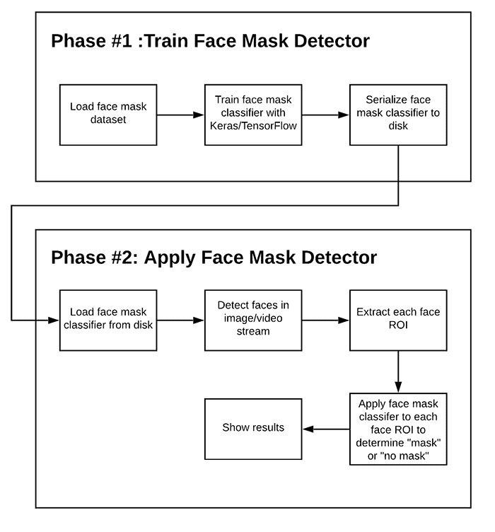**Fig -1 Flow chart**

In order to train a face mask detector, we need to break our project into two parts as shown by Fig 1 above:

* **Training:**Here we will focus on loading our face mask detection dataset from disk, training a model (using Keras/TensorFlow) on this dataset, and then serializing the face mask detector to disk
* **Deployment:**Once the face mask detector is trained, we can then move on to loading the mask detector, performing face detection, and then classifying each face as with mask or without mask.

We will use these images to build a CNN model using TensorFlow to detect if you are wearing a face mask by using the webcam of your PC.

**2.4 Model Architecture**

**CNN Architecture:**

The proposed model uses deep learning with CNN (Convolutional Neural Network) architecture. CNN is a type of deep learning algorithm which is very useful for pattern recognition from images [8]. A CNN is a multilayer neural network that was biologically inspired by the animal visual cortex. The architecture is particularly useful in image-processing applications. A CNN typically has three layers: a convolutional layer, a pooling layer, and a fully connected layer. The network comprises an input layer, several hidden layers, and an output layer. The hidden layers consist of multiple convolution layers that learn suitable filters for important feature extraction from the given samples. The features extracted by CNN are used by multiple dense neural networks for classification purposes. The architecture contains three pairs of convolution layers each followed by one max pooling layer. This layer decreases the spatial size of the representation and thereby reduces the number of parameters. As a result, the computation is simplified for the network. Then, a flatten layer reshapes the information into a vector to feed into the dense network. Three pairs of dense and dropout layers learn parameters for classification. The dense layer comprises a series of neurons each of them learn nonlinear features. The dropout layer prevents the network from overfitting by dropping out units. Finally, a dense layer containing two neurons distinguishes the classes. In addition to image processing, the CNN has been successfully applied to video recognition and various tasks within natural language processing.

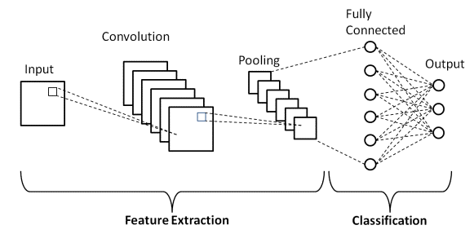

**Fig:2 Different Layers of CNN Architecture**

There are three types of layers that make up the CNN which are the convolutional layers, pooling layers, and fully-connected layers. When these layers are combined, a CNN architecture is formed. The fully connected layer, which processes the final output that represents the prediction about the image. The architecture contains the initial fully convolution layer with 32 filters, followed by 19 residual bottleneck layers

**CHAPTER 03 IMPLEMENTATION**

**3.1 Dataset used in the minor project.**

The dataset used in a face mask detection system project can vary depending on the specific project and its requirements. However, some commonly used datasets for this task include:

The "Face Mask Detection" dataset by Pranja Bhandari: This dataset contains over 1,000 images of people with and without face masks in various settings.

The "Medical Mask Dataset" by Dr. Wei Shen and Dr. Gary Qian: This dataset contains over 5,000 images of people wearing medical masks.

The "COVID-19 Mask Image Dataset" by Rinaldi et al.: This dataset contains over 6,000 images of people with and without face masks, with a focus on COVID-19 mask types.

The "MUG Facial Expression Database" by Egidio Falotico et al.: This dataset contains over 3,000 images of faces with different expressions, including some images of people wearing face masks.

These are just a few examples, and there are many other datasets available for this task. But the dataset we have used in our project we have downloaded it from Kaggle. And our project also works on live time in which we have no need of dataset.

**3.2 Dataset Features**

**3.2.1 Types of Datasets**

The dataset we have used in our project contains images of peoples wearing mask or not. Our dataset contains two folders named as with_mask or without_mask. In with_mask folder the folder contains about 4000 images of people wearing mask used for detection when the code is executed. And just like that the second folder contains images of people not wearing masks which is also used for detection that people had wear mask or not.

**3.2.2 Number of Attributes, fields, description of the data set**

A face mask detection dataset typically includes the following attributes or fields:

Image: This is the field that contains the image of a person's face.

Class: This field specifies whether the person in the image is wearing a face mask or not. It is usually represented as a binary variable, where 1 indicates that the person is wearing a face mask, and 0 indicates that they are not.

Location: This field specifies the location where the image was captured, such as a public space, office, hospital, etc.

Camera angle: This field specifies the angle at which the image was captured, such as front-facing, side-facing, etc.

Lighting conditions: This field specifies the lighting conditions under which the image was captured, such as low-light, bright light, etc.

Age and gender: These fields specify the age and gender of the person in the image.

Type of mask: If the dataset includes images of people wearing masks, this field specifies the type of mask worn, such as a surgical mask, N95 mask, cloth mask, etc.

**3.3 Design of Problem Statement**

In the wake of the COVID-19 pandemic, it has become increasingly important to enforce the use of face masks in public spaces. However, it can be challenging for individuals to monitor every person entering a public space and ensure that they are wearing a mask. Therefore, a face mask detection system is required that can automatically detect whether an individual is wearing a mask or not. The system should be able to process real-time video feeds from cameras placed at the entrances of public spaces and flag any individuals who are not wearing masks. This system should be accurate and efficient, as it is critical to ensuring the safety of individuals in public spaces. The project aims to develop such a face mask detection system using machine learning and computer vision techniques, and evaluate its performance on a real-world dataset.This problem statement clearly outlines the need for a face mask detection system and highlights the challenges that individuals face in monitoring mask usage. It also defines the requirements for the system in terms of accuracy, efficiency, and real-time processing capabilities. The statement also specifies the use of machine learning and computer vision techniques to develop the system and emphasizes the need for evaluation on a real-world dataset.

**3.4 Algorithm / Pseudo code of the Project Problem**

The pseudocode for the project is -:

* Load the face mask detection dataset
* Split the dataset into training and testing sets
* Load the pre-trained face detection model (e.g., Haar Cascade classifier)
* Load the pre-trained face mask detection model (e.g., Convolutional Neural Network)
* Initialize the webcam or the video stream from a file
* Loop over each frame in the video stream
* Apply the face detection model to detect faces in the frame
* For each detected face, extract the face region
* Apply the face mask detection model to predict whether the face is wearing a mask or not
* Draw a bounding box around the face and label it as "with mask" or "without mask" depending on the prediction
* Display the frame with the bounding boxes and labels
* End the loop when the video stream is completed or the user presses the "Q" key
* Calculate the accuracy, precision, recall, and F1 score of the face mask detection model on the testing set
* Save the trained face mask detection model for future use

**3.5 Flow graph of the Minor Project Problem**

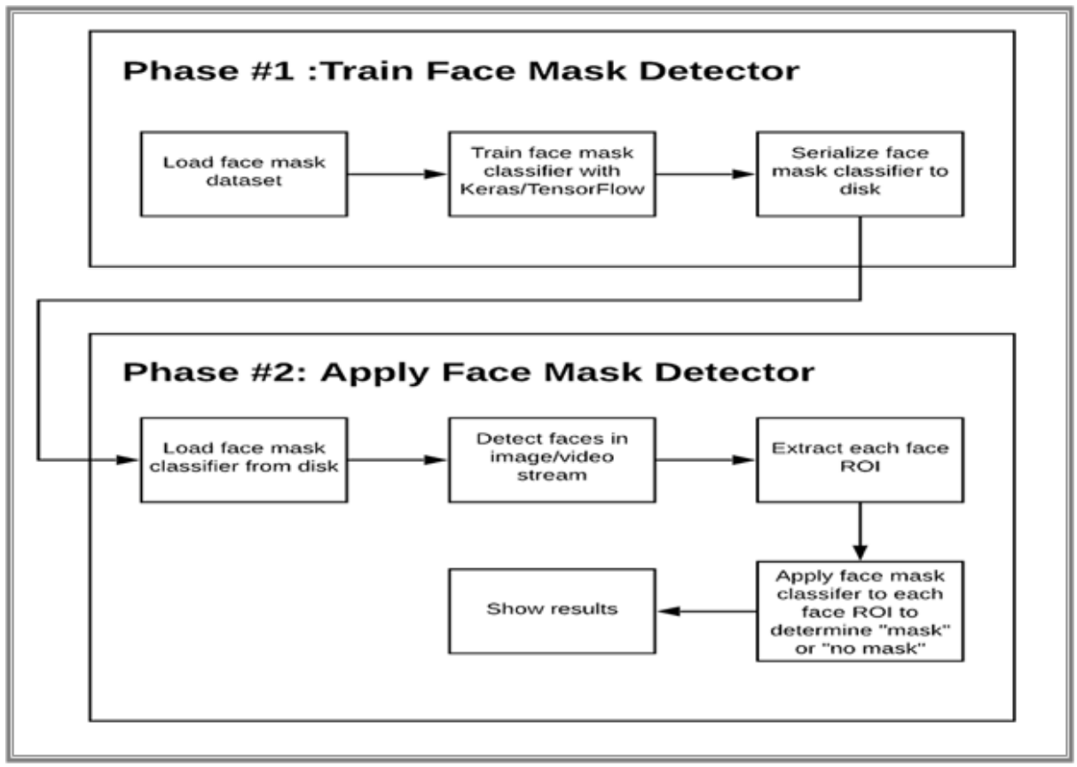

**Fig -3 Flow Graph**

**3.6 Screen shots of the various stages of the Project (For Real time )**

* **Step -1:Importing the required libraries:**



**Fig -4 Libraries**

* **Step -2:**

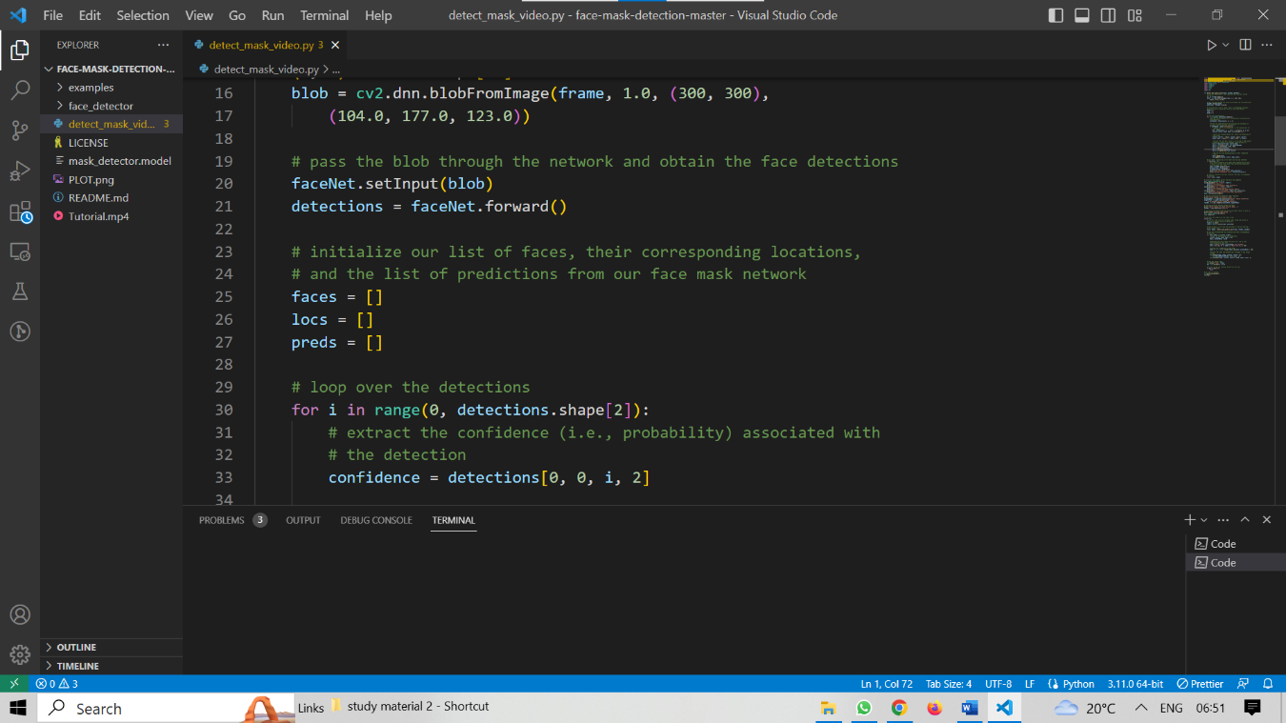

**Fig -5 Code**

* **Step -3 :**

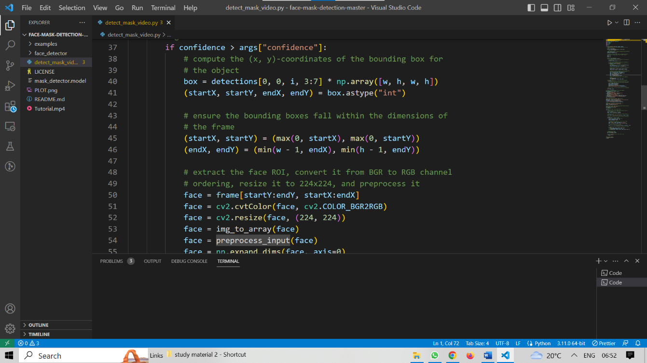

**Fig -6 Code**

* **Step -4:**



**Fig -7 Code**

* **Step -5 :**

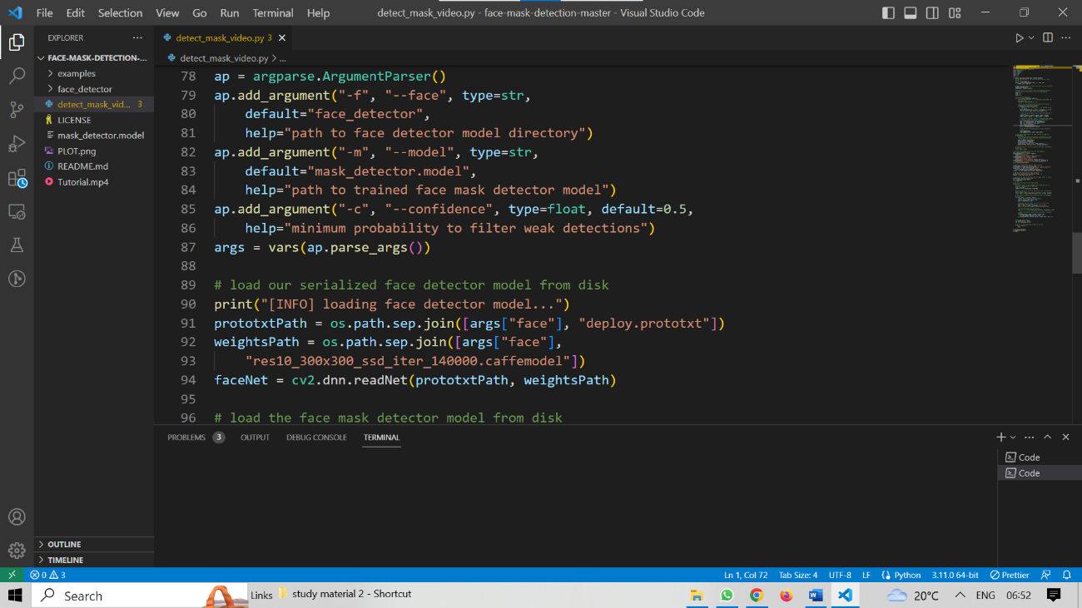

**Fig -8 Code**

* **Step -6:**

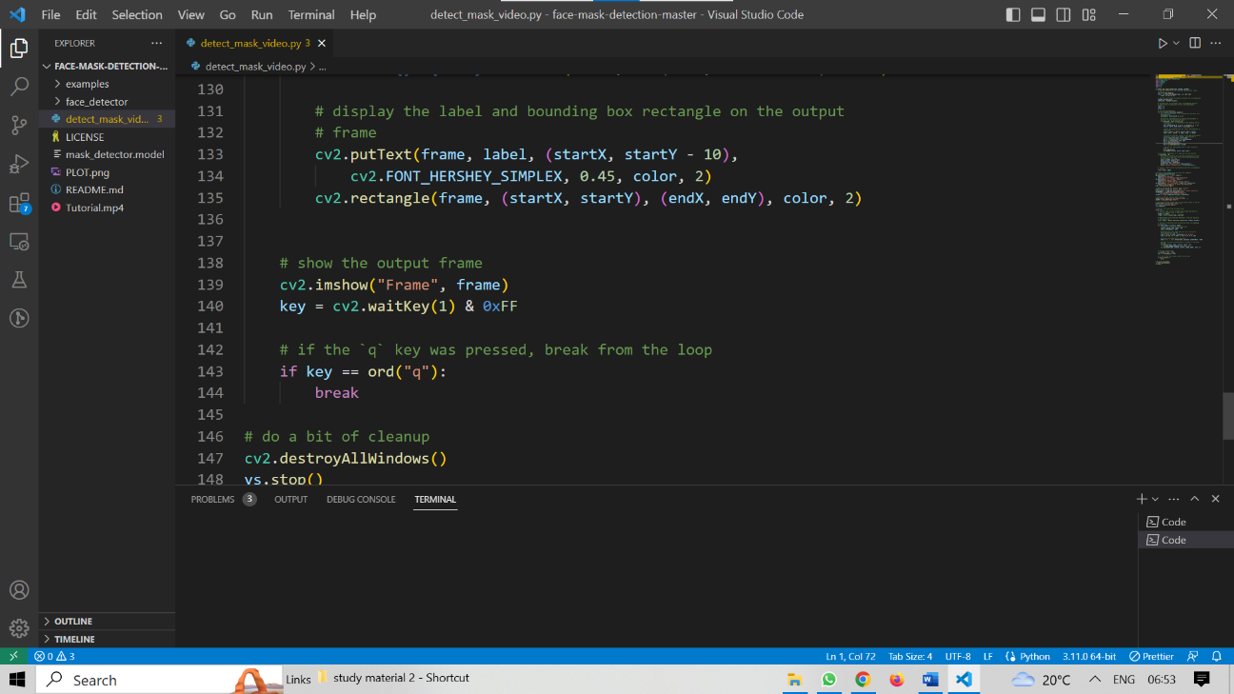

**Fig -9 Code**

* **Step -7 : OUTPUT – (With Mask)**

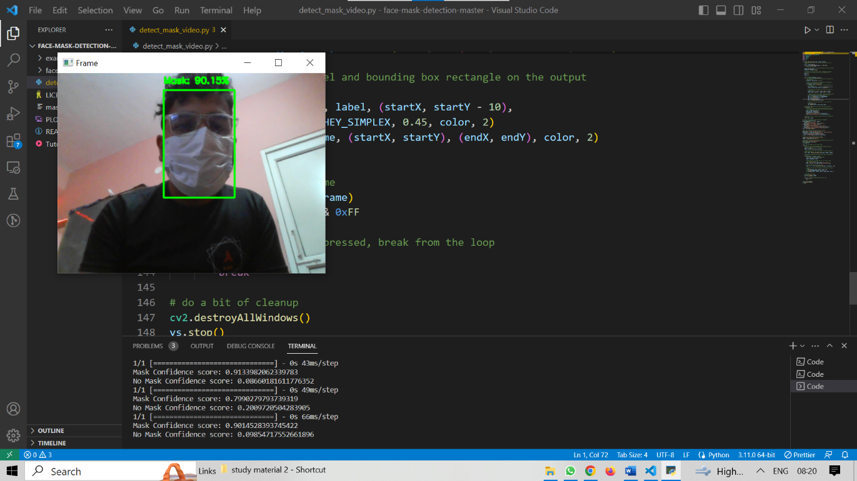

**Fig -10 Output(with_mask)**

* **Step -8 : OUTPUT – (Without_Mask)**

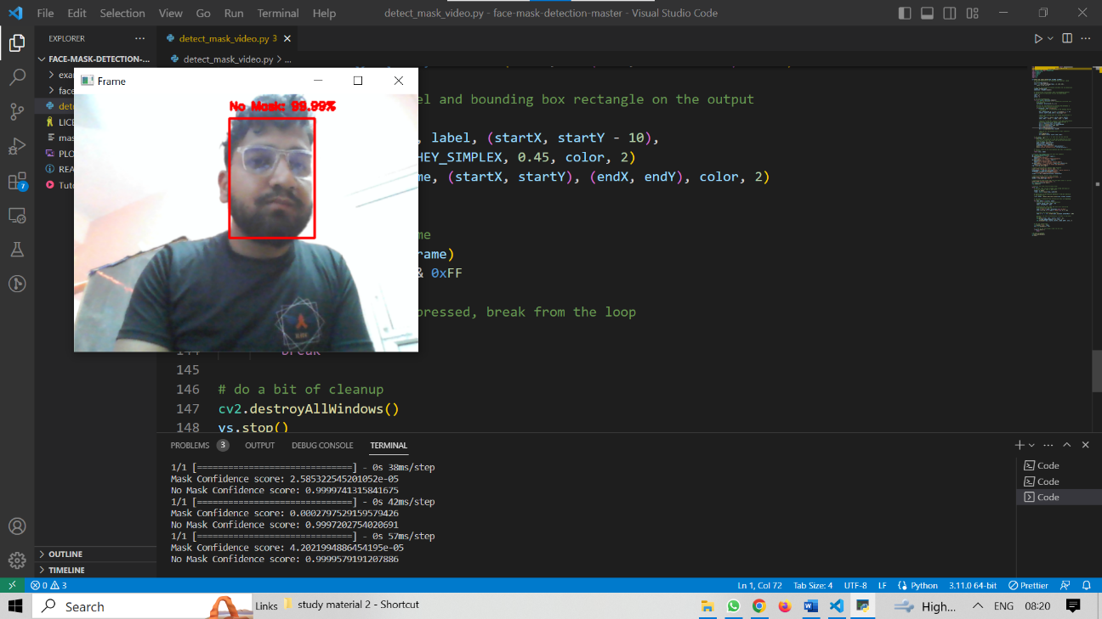

**Fig -11 Output(without_mask)**

**3.6 Screen shots of the various stages of the Project (For image detection from dataset)**

* **Step -1:Importing the required libraries:**

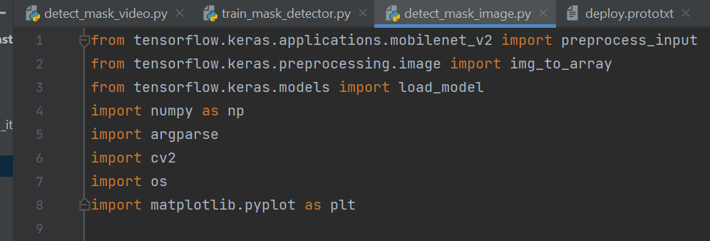

**Fig -12 Importing libraries**

* **Step -2: construct the argument parser and parse the arguments**

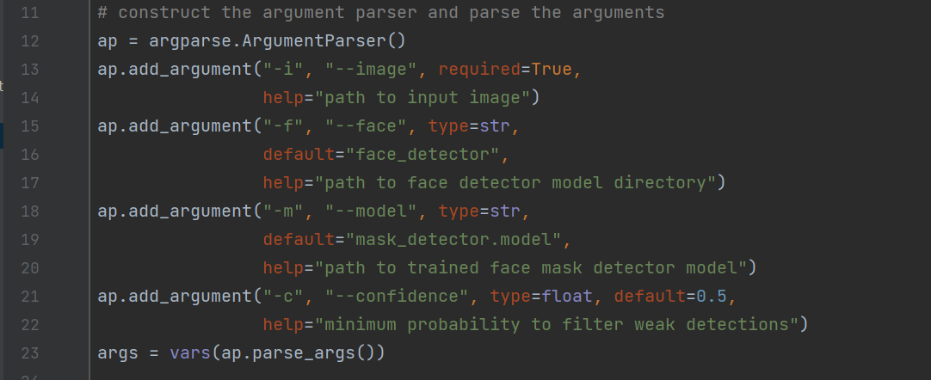

**Fig -12 Importing libraries**

* **Step -3: Load face mask detector and input image from disk:**

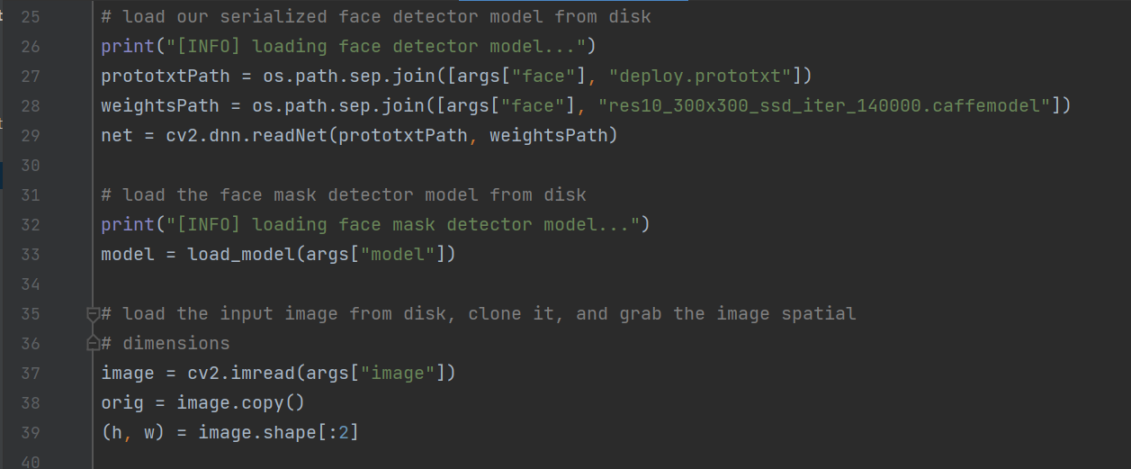

**Fig -13 Code**

* **Step -4: Construct blob from the image :**

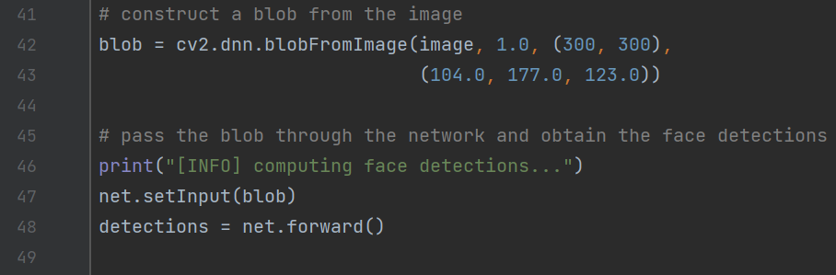

**Fig -14 Code**

* **Step -5: Loop over the image :**

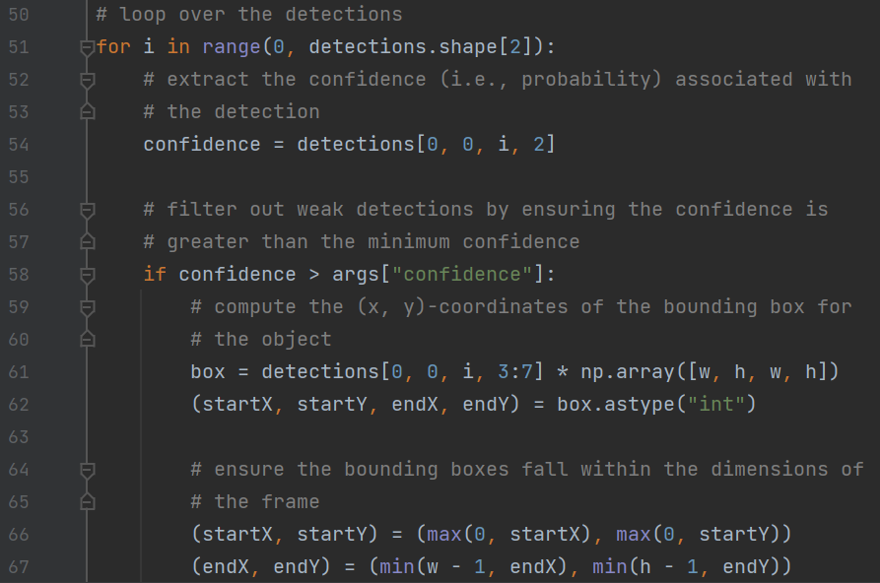

**Fig -15 Code**

* **Step -6: Extracting the face ROI :**

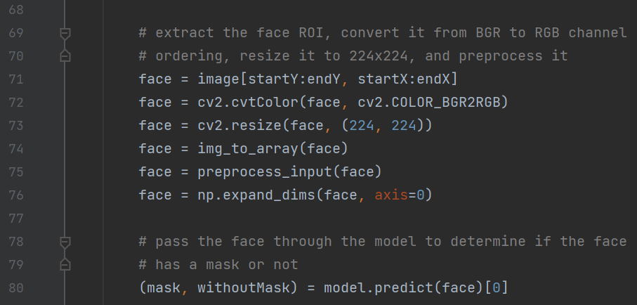

**Fig -16 Code**

* **Step -7: Extracting the face ROI :**

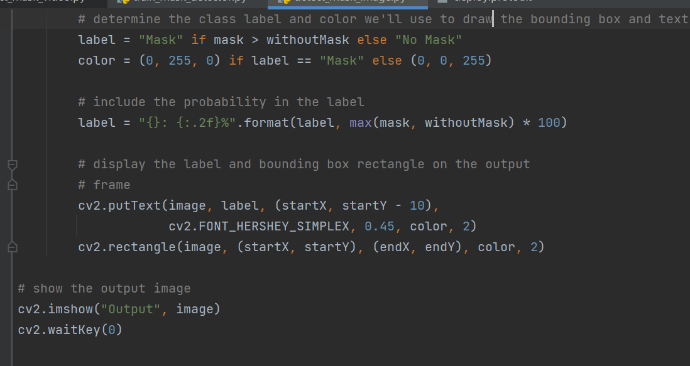

**Fig -17 Code**

* **Step -8: Output :**

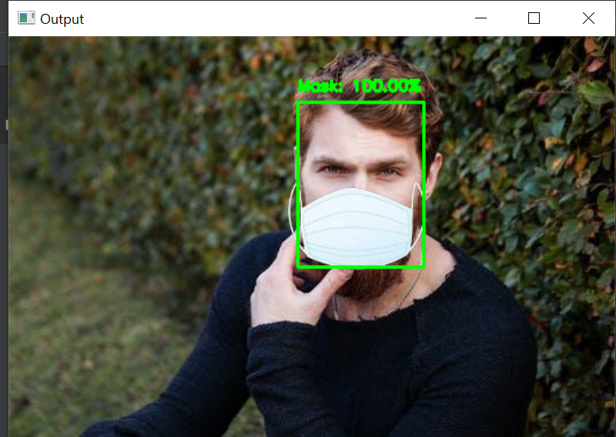

**Fig – 18 Output**

**Chapter 04: RESULTS**

**4.1 Discussion on the Results Achieved-**

The results achieved in a face mask detection project can vary depending on several factors, such as the quality of the dataset, the performance of the pre-trained models used for face detection and face mask detection, the choice of the deep learning architecture, and the hyperparameters of the model. However, here are some general points to consider when discussing the results of a face mask detection project:

1.Accuracy: One of the key metrics for evaluating the performance of a face mask detection system is its accuracy. The accuracy measures the percentage of correctly predicted face mask labels over all the face samples in the testing set. Typically, an accuracy of over 90% is desirable for a reliable face mask detection system.

2.Precision and Recall: Precision and recall are two other important metrics for evaluating the performance of a face mask detection system. Precision measures the percentage of correctly predicted "with mask" labels among all the predicted "with mask" labels, while recall measures the percentage of correctly predicted "with mask" labels among all the actual "with mask" labels. High precision and recall scores indicate that the system is correctly identifying faces with masks while avoiding false positives (i.e., misidentifying faces without masks as having masks).

3.False Positive Rate: False positive rate (FPR) is another important metric for evaluating the performance of a face mask detection system. FPR measures the percentage of falsely predicted "with mask" labels among all the actual "without mask" labels. A high FPR can be a concern as it may lead to unnecessary interventions (e.g., stopping people without masks from entering a public space).

4.Speed: The speed of the face mask detection system is also an important consideration, especially for real-time applications. A fast and efficient system can process a large number of video frames in real-time and provide timely feedback to the users.

Overall, the results achieved in a face mask detection project should be evaluated based on a combination of these metrics, and they should be compared to the state-of-the-art face mask detection systems to ensure that the system is performing well. Additionally, the results should be interpreted in the context of the specific application of the face mask detection system, such as enforcing the use of masks in public spaces during the COVID-19 pandemic.

**4.2 Applications**

The face mask detection model has various applications in the context of public health and safety. Some of them include:

**1. Monitoring Compliance:** The model can be used to monitor public spaces, such as airports, train stations, or shopping malls, to ensure that every individual is wearing face mask or not. It can help authorities identify and address those issues and take appropriate measures to enforce mask-wearing policies.

**2. Crowd Control:** In crowded areas, such as concerts, sporting events, or protests, the model can be deployed to identify individuals who are not wearing masks. This information can be used to manage crowd movement, enforce mask mandates, and maintain social distancing measures.

**3. Workplace Safety:** Many workplaces have implemented face mask policies to protect their employees. The face mask detection model can be integrated with surveillance systems to ensure compliance with these policies. It can help identify areas where mask usage is low and enable targeted interventions to improve safety measures.

**4. Public Transportation:** Public transportation systems, such as buses, trains, or subways, can benefit from face mask detection. The model can be used to identify passengers without masks and trigger alerts for immediate action by transportation staff or authorities.

**5. Healthcare Facilities**: Face mask detection can be employed in hospitals, clinics, or nursing homes to ensure that healthcare providers, patients, and visitors are wearing masks appropriately. It can contribute to infection control efforts and reduce the risk of transmission within healthcare settings.

**6. Automated Access Control:** Face mask detection can be integrated with access control systems to allow or deny entry to individuals based on mask compliance. It can be useful in places like schools, offices, or residential buildings to regulate entry and maintain a safe environment.

**7. Real-time Monitoring:** The model can provide real-time data on mask usage in different areas, allowing health authorities to identify trends, hotspot areas, or regions with low compliance. This information can aid in decision-making processes and resource allocation for public health interventions.

**4.3 Limitation**

The developed system faces difficulties in classifying faces covered by hands since it almost looks like the person wearing a mask. While any person without a face mask is traveling on any vehicle, the system cannot locate that person correctly. For a very densely populated area, distinguishing the face of each person is very difficult. For this type of scenario, identifying people without face mask would be very difficult for our proposed system. In order to get the best result out of this system, the city must have many CCTV cameras to monitor the whole city as well as dedicated manpower to enforce proper laws on the violators. Since the information about the violator is sent via SMS, the system fails when there is a problem in the network. The proposed system mainly detects the face mask and informs the corresponding authority with the location of a person not wearing a mask. Based on this, the authority has to send their personnel to find out the person and take necessary actions. But this manual scenario can be automated by using drones and robot technology to take action instantly.

**4.4 Future Work**

The future scope for face mask detection models is quite promising. Here are some potential areas of development and expansion:

**1. Mask Type Differentiation:** Current face mask detection models primarily focus on detecting the presence or absence of a mask. Future models could be designed to differentiate between different types of masks, such as surgical masks, N95 respirators, cloth masks, or face shields. This could provide more specific information about the level of protection individuals are using.

**2. Mask Compliance Analysis:** Rather than only detecting mask presence, future models could analyze the quality of mask usage. For example, they could determine if masks are worn correctly, covering both the nose and mouth. This would enable more nuanced insights into compliance levels and provide feedback to individuals on proper mask usage.

**3. Integration with Access Control Systems:** Face mask detection models can be integrated with access control systems to automate the process of allowing or denying entry based on mask compliance. This would enhance safety protocols in various settings, such as airports, office buildings, or event venues.

**4.5 Conclusion**

This model proposes a smart city system to reduce the spread of coronavirus by reporting people who are not wearing masks, which acts as a protection for preventing the spread of COVID-19. The model includes a face mask detection system to detect patterns in which a deep learning algorithm is used to detect the face of the people. To train the model, labelled image data were used, where the images were masked and unmasked face images. The decision of the distribution network is sent to the relevant authority. The system proposed in this study would be, an important tool to prevent the spread of virus by strictly imposing the use of face mask in public places for all people.

**References**

[1] WHO EMRO | About COVID-19 | COVID-19 | Health topics. [Online]. Available: http://www.emro.who.int/health-topics/coronavirus/about-covid-19.html, accessed on: Jul. 26, 2020.

[2] Worldometer, “Coronavirus Cases,”. [Online]. Available: <https://www.worldometers.info/coronavirus>,

[3] Ieamsaard, Jirarat, Surapon Nathanael Charoensook, and Suchart Yammen. "Deep learning-based face mask detection using yolov5." *2021 9th International Electrical Engineering Congress (iEECON)*. IEEE, 2021.

[4] N. Sharma, R. Sharma, N. Jindal, Machine learning and deep learning applications-a vision, Global Trans. Proc.

[5] Liu, S., Qi, L., Qin, H., Shi, J., & Jia, J. (2018). Using a network for instance segmentation. In Proceedings of the IEEE conference on computer vision.

[6] Z. Zhang, B. Bowes, The future of artificial intelligence (AI) and machine learning (ML) in landscape design: a case study in coastal Virginia, USA, J. Digital Landscape Arch. 2019 (4) (2019).

[7] Nishiura, H., Kobayashi, T., Miyama, T., Suzuki, A., Jung, S. M., Hayashi, K., ... & Linton, N. M. (2020). Estimation of the asymptomatic ratio of novel coronavirus infections (COVID-19). International Journal of infectious diseases, 94, 154.

[8] A. Khan, A. Sohail, U. Zahoora, and A. S. Qureshi, “A Survey of the Recent Architectures of Deep Convolutional Neural Networks,” Artif. Intell. Rev., Jan. 2019.